ACADEMIC ADVISING RESOUCE CENTER

  - Newsletter— September 26, 2024
  - 

GOT A QUESTION? ask advising.
The Academic Advising Resource Center (AARC) is located in the Conlan Center, around the corner from the Registrar Office. Our team is here to help you any and all academic or advising questions. Drop-ins are welcome!

important deadlines
Need to withdraw from a class? Get all the signatures you need asap to avoid getting an “F” on your transcript. Dropping a full-semester class with a “W” before October 25 will not affect your GPA. So click here to print an add/drop form, then set up a meeting with your advisor pronto! Online or accelerated class drop and withdrawal dates are located here (or on myMount under the Academics tab: Registrar’s Office page: Dates to Know S125.)

Pass Program
If you’re taking part in the PASS Program, remember you need to meet with Jadah Jackson every two weeks. If you missed a meeting, email Jadah asap to get back on schedule: jadah.jackson@msj.edu. New to PASS? Learn more about it here: https://www.msj.edu/academics/academic-resources/pass-program/index.html.

life hacks with bpw

Q: Wondering why happiness is fleeting? Feeling unhappy more often than not?
A: You’re human—and that’s ok. Take advice from Arthur Brooks, a Harvard professor and happiness researcher: “Happiness is not a destination. [It]’s a direction.” In Build the Life You Want, co-written with Oprah Winfrey, Brooks says our goal shouldn’t be happiness. Rather, our goal should be to become happier. When you’re feeling down, happiness is like a miracle at the top of a really tall mountain. Happier is a less insurmountable climb. It’s a step in the direction of happiness. If you’re low, focus on small, achievable changes in mood. Forget mountains.

Humans are neurochemically hard-wired to experience ups and downs. Don’t believe me? Google “dopamine.” Bottom line, there’s nothing wrong with you if you’re not always, completely, social-media-perfect happy every dang minute of the day. (Was it Herman Melville who said 3/5ths of life is melancholy? I’m cool with it—because the other 2/5ths are sweeter by comparison.) So when you feel “meh,” don’t panic. “Not happy” doesn’t have to mean “unhappy.” It’s all a spectrum. And remember, happier is always only a small step or two away.

Check out this short, witty interview with Arthur Brooks here.

*Note: “Not happy” and “depressed” are very different things. If you’re unhappy all of the time, or you no longer find enjoyment in things that used to make you happy, please get in touch with the Wellness center.

KATE’S CORNER (academic survival tips)
Resilience is one of the core skills to develop in college and can help you navigate the many challenges that arise during your college years. College is stressful and everyone experiences setbacks, whether it’s a poor grade, not getting a preferred internship, or missing out on a scholarship. By developing resilience, you are better equipped to maintain emotional balance, manage anxiety, and approach challenges with optimism, contributing to overall mental health that leads to success both in college and beyond.

Check out these links to hone in on possible mistakes you are making and to develop resilience to move forward:
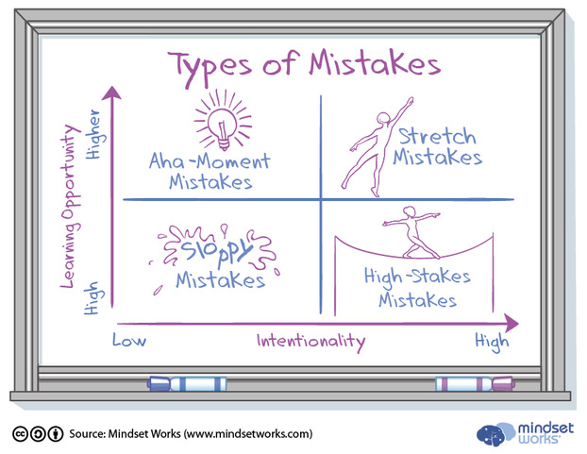
Why Understanding These Four Types of Mistakes Can Help Us Learn
kqed.org


How to Build Resilience During College—When it Matters Most
hbr.org

LIBRARY SUPPORT
Did you know that MSJ librarians can be your partners in academic success? From locating books and articles to developing search strategies and using citation tools, librarians are here for you! Walk-in for research support during weekdays from 8am-4pm OR schedule an appointment for in-person or Zoom assistance.

Wellness Tips
September is Suicide Prevention Awareness month, and we invite you to join Peers Advocating for Wellness and Safety (PAWS) and the Wellness Center in raising awareness for mental health by participating in the Virtual Warrior Run. The event will take place in the Centennial Field House on Monday, September 30th from 3:00 PM to 4:30 PM. You can register by following this link: Virtual Warrior Run Registration. Let’s come together to support mental health awareness and make a difference!

FOLLOW US ON INSTAGrAM!
Keep up with crucial dates and info about advising by following msj_advising on Instagram. We’ll be launching soon with a brand new logo and helpful tips and timelines for students. Follow us now so you’re ready later!

