ACADEMIC ADVISING RESOURCE CENTER

  - Newsletter— October 24, 2024
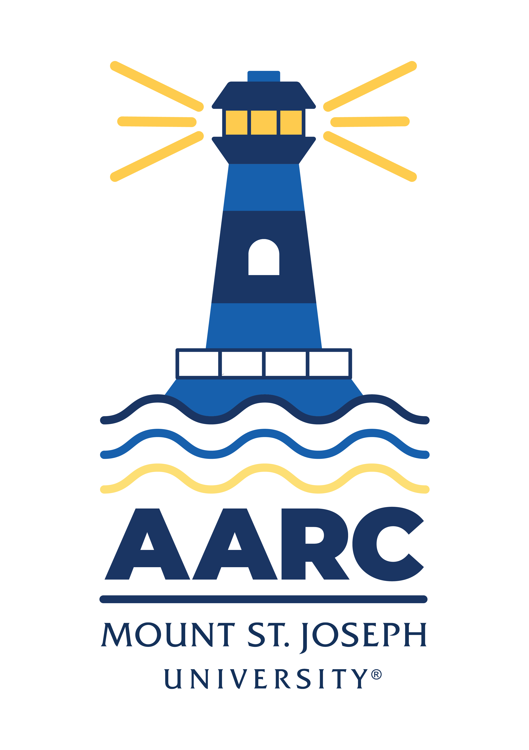

GOT A QUESTION? ask advising.

The Academic Advising Resource Center (AARC) is located in the Conlan Center, around the corner from the Registrar Office. Our team is here to help you any and all academic or advising questions. Drop-ins are welcome!

important deadlines

It’s advising season, y’all! Be sure to check your department advising schedules, so you can book a time to meet with your faculty advisor in the next couple of weeks. If you need advice before you meet with your advisor, give us a shout (advising@msj.edu). We’re more than happy to help you prepare for your meeting with advisors.

Not sure how to go about this whole advising/registration thing? Don’t know who your advisor is or how to look up course schedules? Read the attached PDF “Advising Scheduling” for step-by-step tips and instructions.

The advising period for S225 and S425 is October 21-November 1. You’ll need to meet with your faculty advisor during this period before you register for classes. Here are the registration dates in November:

Honors Program/Veteran November 4 at 9:00 a.m.
Seniors/Graduate/Doctorate November 5 at 6:00 a.m.
Juniors November 7 at 6:00 am, 6:30 am, 7:00 am, and 7:30 am
Sophomores November 12 at 6:00 am, 6:30 am, 7:00 am, and 7:30 am
Freshman November 14 at 6:00 am, 6:30 am, 7:00 am, and 7:30 am
New Students November 15 at 8:30 a.m.
*S425 Registration begins in February 2025

Be sure, too, to check your midterm grades on mymount in all your classes in the coming weeks:

Midterm Grades for full semester and Plan A1 October 14 - October 21
Midterm Grades for Plan A2 October 14 - October 21

Still need to withdraw from a class? Get all the signatures you need asap to avoid getting an “F” on your transcript. Dropping a full-semester class with a “W” before October 25 will not affect your GPA. So click here to print an add/drop form, then set up a meeting with your advisor pronto! Online or accelerated class drop and withdrawal dates are located here (or on myMount under the Academics tab: Registrar’s Office page: Dates to Know S125.)

life hacks with bpw

Q: Can I pretty please just take a break from growing and striving and grinding and learning and bettering myself and all this advice everyone is giving me and take a nap on the quad in the sun for an hour instead?

A: OMG yes! But only if you listen to this Nick Drake song while you drift off into your restorative dreamscapes.

KATE’S CORNER (academic survival tips)

The follow-up course to Mount 101 is premiering in the spring semester! FYE 102 (Wednesdays at 12pm or 1pm) will focus on developing leadership skills, effective communication, team building, and more, along with helping to build and implement the First-Year Peer Mentoring Program that kicks off next fall.

Contact Kate (kathryn.mitchell@msj.edu | 937.598.9771) with any questions. Anyone can register!

Course Description: FYE 102 is designed to continue the work of FYE 101, and to cultivate essential leadership skills/styles, foster team-building capabilities, and enhance effective communication techniques in a collaborative setting. Additionally, the course will focus on the creation and implementation of a peer mentoring program aimed at supporting first-year college students. This course is ideal for students interested in leadership roles, student government, or campus organizations, and for those looking to make a positive impact on the college community.

Course Learning Outcomes:
- LO1: Develop personal leadership style and strengths.
- LO2: Master team-building and collaboration techniques.
- LO3: Enhance verbal and written communication skills for leadership.
- LO4: Design and participate in a peer mentoring program.
- LO5: Gain practical experience in mentoring first-year students.

LIBRARY SUPPORT

Research Help Tips: Information within a Citation

Knowing the various parts of a citation, and where each part is located, can help you read citations, no matter the citation style! Reading a citation can help you know if a referenced source is a book, a book chapter, or a journal article. This information can assist you in determining whether to read the referenced source or to locate common journals for your research topic.

Wellness Tips

The Wellness Center encourages you to continue prioritizing your mental and physical well-being. We invite you to join us at our upcoming Wellness events—or to take a moment for a Happiness Break with a guided breathwork practice led by Dr. Spiegel, featured on the Greater Good Podcast series.

Pass Program

If you’re taking part in the PASS Program, remember you need to meet with Jadah Jackson every two weeks. If you missed a meeting, email Jadah asap to get back on schedule: jadah.jackson@msj.edu. New to PASS? Learn more about it here: https://www.msj.edu/academics/academic-resources/pass-program/index.html.

FOLLOW US ON INSTAGrAM!
Keep up with crucial dates and info about advising by following msj_advising on Instagram. We’ll be launching soon with a brand new logo and helpful tips and timelines for students. Follow us now so you’re ready later!

