ACADEMIC ADVISING RESOURCE CENTER

  - Newsletter— October 10, 2024
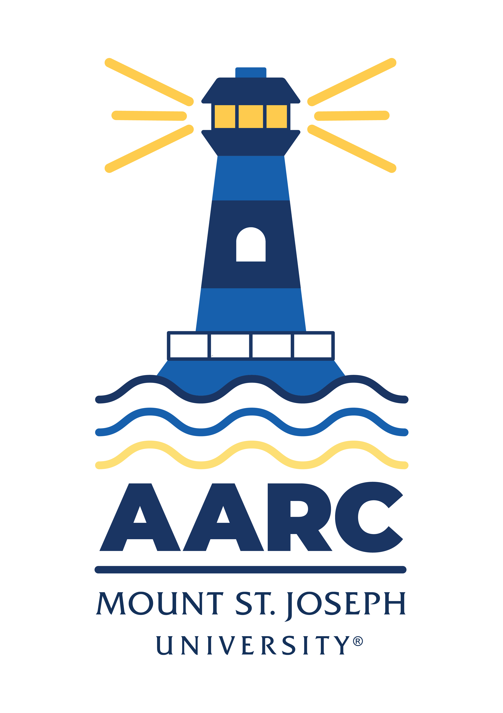

GOT A QUESTION? ask advising.
The Academic Advising Resource Center (AARC) is located in the Conlan Center, around the corner from the Registrar Office. Our team is here to help you any and all academic or advising questions. Drop-ins are welcome!

important deadlines
It’s advising season, y’all! Be sure to check your department advising schedules, so you can book a time to meet with your faculty advisor in the next couple of weeks. If you need advice before you meet with your advisor, give us a shout (advising@msj.edu). We’re more than happy to help you prepare for your meeting with advisors.

Not sure how to go about this whole advising/registration thing? Don’t know who your advisor is or how to look up course schedules? Read the attached PDF “Advising Scheduling” for step-by-step tips and instructions.

The advising period for S225 and S425 is October 21-November 1. You’ll need to meet with your faculty advisor during this period before you register for classes. Here are the registration dates in November:

Honors Program/Veteran November 4 at 9:00 a.m.
Seniors/Graduate/Doctorate November 5 at 6:00 a.m.
Juniors November 7 at 6:00 am, 6:30 am, 7:00 am, and 7:30 am
Sophomores November 12 at 6:00 am, 6:30 am, 7:00 am, and 7:30 am
Freshman November 14 at 6:00 am, 6:30 am, 7:00 am, and 7:30 am
New Students November 15 at 8:30 a.m.
*S425 Registration begins in February 2025

Be sure, too, to check your midterm grades on mymount in all your classes in the coming weeks:

Midterm Grades for full semester and Plan A1 October 14 - October 21
Midterm Grades for Plan A2 October 14 - October 21

Still need to withdraw from a class? Get all the signatures you need asap to avoid getting an “F” on your transcript. Dropping a full-semester class with a “W” before October 25 will not affect your GPA. So click here to print an add/drop form, then set up a meeting with your advisor pronto! Online or accelerated class drop and withdrawal dates are located here (or on myMount under the Academics tab: Registrar’s Office page: Dates to Know S125.)

Pass Program
If you’re taking part in the PASS Program, remember you need to meet with Jadah Jackson every two weeks. If you missed a meeting, email Jadah asap to get back on schedule: jadah.jackson@msj.edu. New to PASS? Learn more about it here: https://www.msj.edu/academics/academic-resources/pass-program/index.html.

life hacks with bpw

Q: Not very “good” at something? Upset with results in a difficult class?
A: Adopt a “growth mindset.” We all internalize an idea that we’re good or bad at some things, inclined to succeed in certain areas while failing in others. But putting value on outcomes, not processes, is a “fixed mindset.” Growth mindset, on the contrary, is focused on effort and resilience. According to Stanford professor Carol Dweck, “The passion for stretching yourself and sticking to it, even (or especially) when it’s not going well, is the hallmark of the growth mindset. This…allows people to thrive during some of the most challenging times in their lives.” Like it or not, we need challenges, difficulty, struggle. Try to redefine failure as a step in the direction of getting better.

Rocky Balboa said it well: “It ain’t about how hard you hit, it's about how hard you can get hit and keep moving forward.” But you don’t have to do it alone. Talk to your professor, advisor, tutor, friend, or counselor about ways you can adopt growth mindset to achieve calm and composure—and to embrace challenges—in the midst of the difficulties life invites you to endure.

Learn more here.

KATE’S CORNER (academic survival tips)
Having an effective study plan is essential for college success, helping you stay organized, manage your time efficiently, and improve retention of material. Click the following to learn more about the key elements of a well-structured study plan:

- Realistic weekly schedule
- Assignment Planning
- Effective study techniques
- Great study space

LIBRARY SUPPORT
Are your professors asking for peer-reviewed journal articles and you aren’t sure where to start? Peer-reviewed articles are located within library databases. You can locate a database under Databases by Subject or Databases by A-Z (if you know what database to use). The “Peer-reviewed” filter can be found on the landing page of most databases or on the left-hand sidebar once you have started searching. As a reminder, peer-reviewed means that the article from research methodology to content has been evaluated by experts in that topic prior to publication.

You can always “Ask a Librarian” for research help by clicking here.

Wellness Tips
For news and information about the Wellness Center, or to make an appointment, click here.

FOLLOW US ON INSTAGrAM!
Keep up with crucial dates and info about advising by following msj_advising on Instagram. We’ll be launching soon with a brand new logo and helpful tips and timelines for students. Follow us now so you’re ready later!

