ACADEMIC ADVISING RESOURCE CENTER

  - Newsletter— November 7, 2024
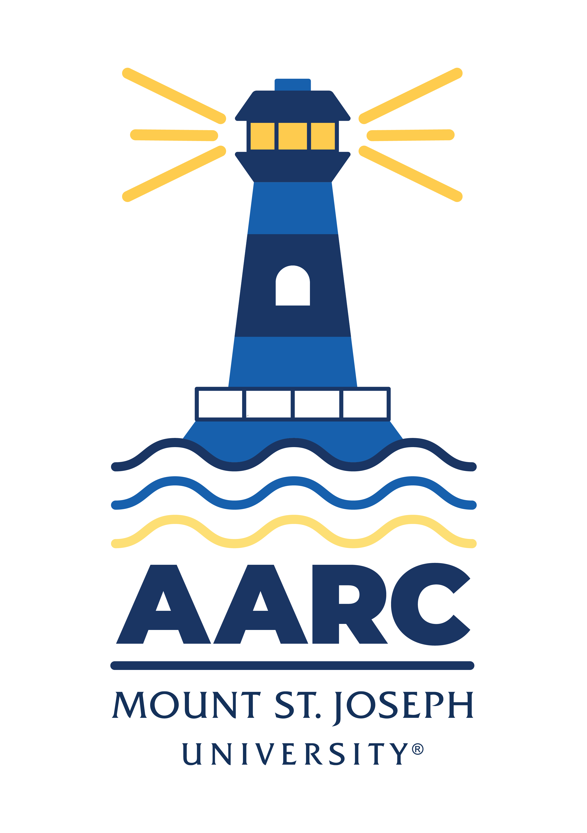

GOT A QUESTION? ask advising.

The Academic Advising Resource Center (AARC) is located in the Conlan Center, around the corner from the Registrar Office. Our team is here to help you any and all academic or advising questions. Drop-ins are welcome!

important deadlines

First-year students who haven’t completed required online trainings will have a hold on their accounts that blocks registration. Questions about that can be directed to peggy.welge@msj.edu.

Advising for S225 is still going strong and registration has opened for some students. If you didn’t meet with your advisor to get cleared to register, you need to see what options are available now. Email us (advising@msj.edu) if you’re in a pickle and need help/advice, or email your advisor asap to check in. Here are the registration dates:

Honors Program/Veteran November 4 at 9:00 a.m.
Seniors/Graduate/Doctorate November 5 at 6:00 a.m.
Juniors November 7 at 6:00 am, 6:30 am, 7:00 am, and 7:30 am
Sophomores November 12 at 6:00 am, 6:30 am, 7:00 am, and 7:30 am
Freshman November 14 at 6:00 am, 6:30 am, 7:00 am, and 7:30 am
New Students November 15 at 8:30 a.m.
*S425 Registration begins in February 2025

If you miss your registration date, it’s okay! Registration stays open until next semester. Email us with questions.

life hacks with bpw

Q: What should I prioritize in November: final papers/exams or missing/late work?

A: Good question. Tough question. Here’s my two cents as a professor.

Put a pin in your late/missing work and prioritize the work ahead of you. It’s crunch time. Hunker down and focus on remaining deadlines. Now may not be the best time to do a deep clean of your kitchen. Or to log three hours a day playing Skyrim. Or to schedule hangouts with your friends. Sometimes we just need to get to work, however painful or boring or stressful it might be. The next four weeks is the time for long hours in the library, for study sessions with classmates, for visiting office hours to get extra help from professors. Make a list of the most important stuff with looming deadlines. That’s what you really need to focus on through finals week.

I know. There’s a temptation at this point in the semester to try and catch up on all the work you’re behind on—but students often sacrifice the work ahead of them trying to catch up on all the work behind them. It’s like looking back at the scenery you missed on a river while your boat is drifting toward a waterfall. Or thinking about a two- point conversion you failed to make in the 2nd quarter while there’s two minutes left in the 4th. If you keep trying to catch a bus that you missed, you’re going to end up missing the next bus, too, and you’ll end up nowhere at all.

My philosophy—but not all professors will agreed, so please talk to yours about your situation—is to focus on the work still out there, and to finish late work after all your final papers and exams are done. Do your best, most concentrated, most knock-their-socks-off good hard work on your remaining assignments. That’ll show your professors you care about finishing well—and if they offer you a chance to submit late or missing work for partial credit after finals are in, spend what energy you have left—when you’ve finished the rest—making up what you can. You may have to cut your losses and take a GPA hit. But it’s better to finish strong with your best efforts than to get stuck in the mud spreading yourself too thin. Put the past on hold for now; embrace the present.

Bonus tip—consider using an Eisenhower Matrix to prioritize your “to do” list. Seriously. It’ll calm things down.

KATE’S CORNER (academic survival tips)

Personal Finance and Budgeting

Financial literacy is crucial to learn in college, equipping you with the skills to manage your finances responsibly and set yourself up for a solid financial future. Check out these links to help you learn how to master your money:

- Budgeting and Money Management in College
- Paying for College
- Credit Building
- 7 Best Budget Apps for Tracking Your Spending, Saving, and Investments

LIBRARY SUPPORT

Tip: Citation within a Database

Need to use unfamiliar citation styles for a class assignment? Utilize the “Cite” feature within databases to quickly generate a citation in that particular style. But remember to review the citation for accuracy!

Wellness Tips

As we wrap up a stressful election season, please pause and try out a guided Self-Compassion Break from Greater Good in Action to ease anxiety. The Wellness Center cares deeply about you and your well-being. Remember, students can make a counseling appointment by calling 513-244-4949 or emailing Wellness.Center@msj.edu.

Pass Program

If you’re taking part in the PASS Program, remember you need to meet with Jadah Jackson every two weeks. If you missed a meeting, email Jadah asap to get back on schedule: jadah.jackson@msj.edu. New to PASS? Learn more about it here: https://www.msj.edu/academics/academic-resources/pass-program/index.html.

FOLLOW US ON INSTAGrAM!
Keep up with crucial dates and info about advising by following msj_advising on Instagram. We’ll be launching soon with a brand new logo and helpful tips and timelines for students. Follow us now so you’re ready later!

