ACADEMIC ADVISING RESOURCE CENTER

  - Newsletter— November 21, 2024
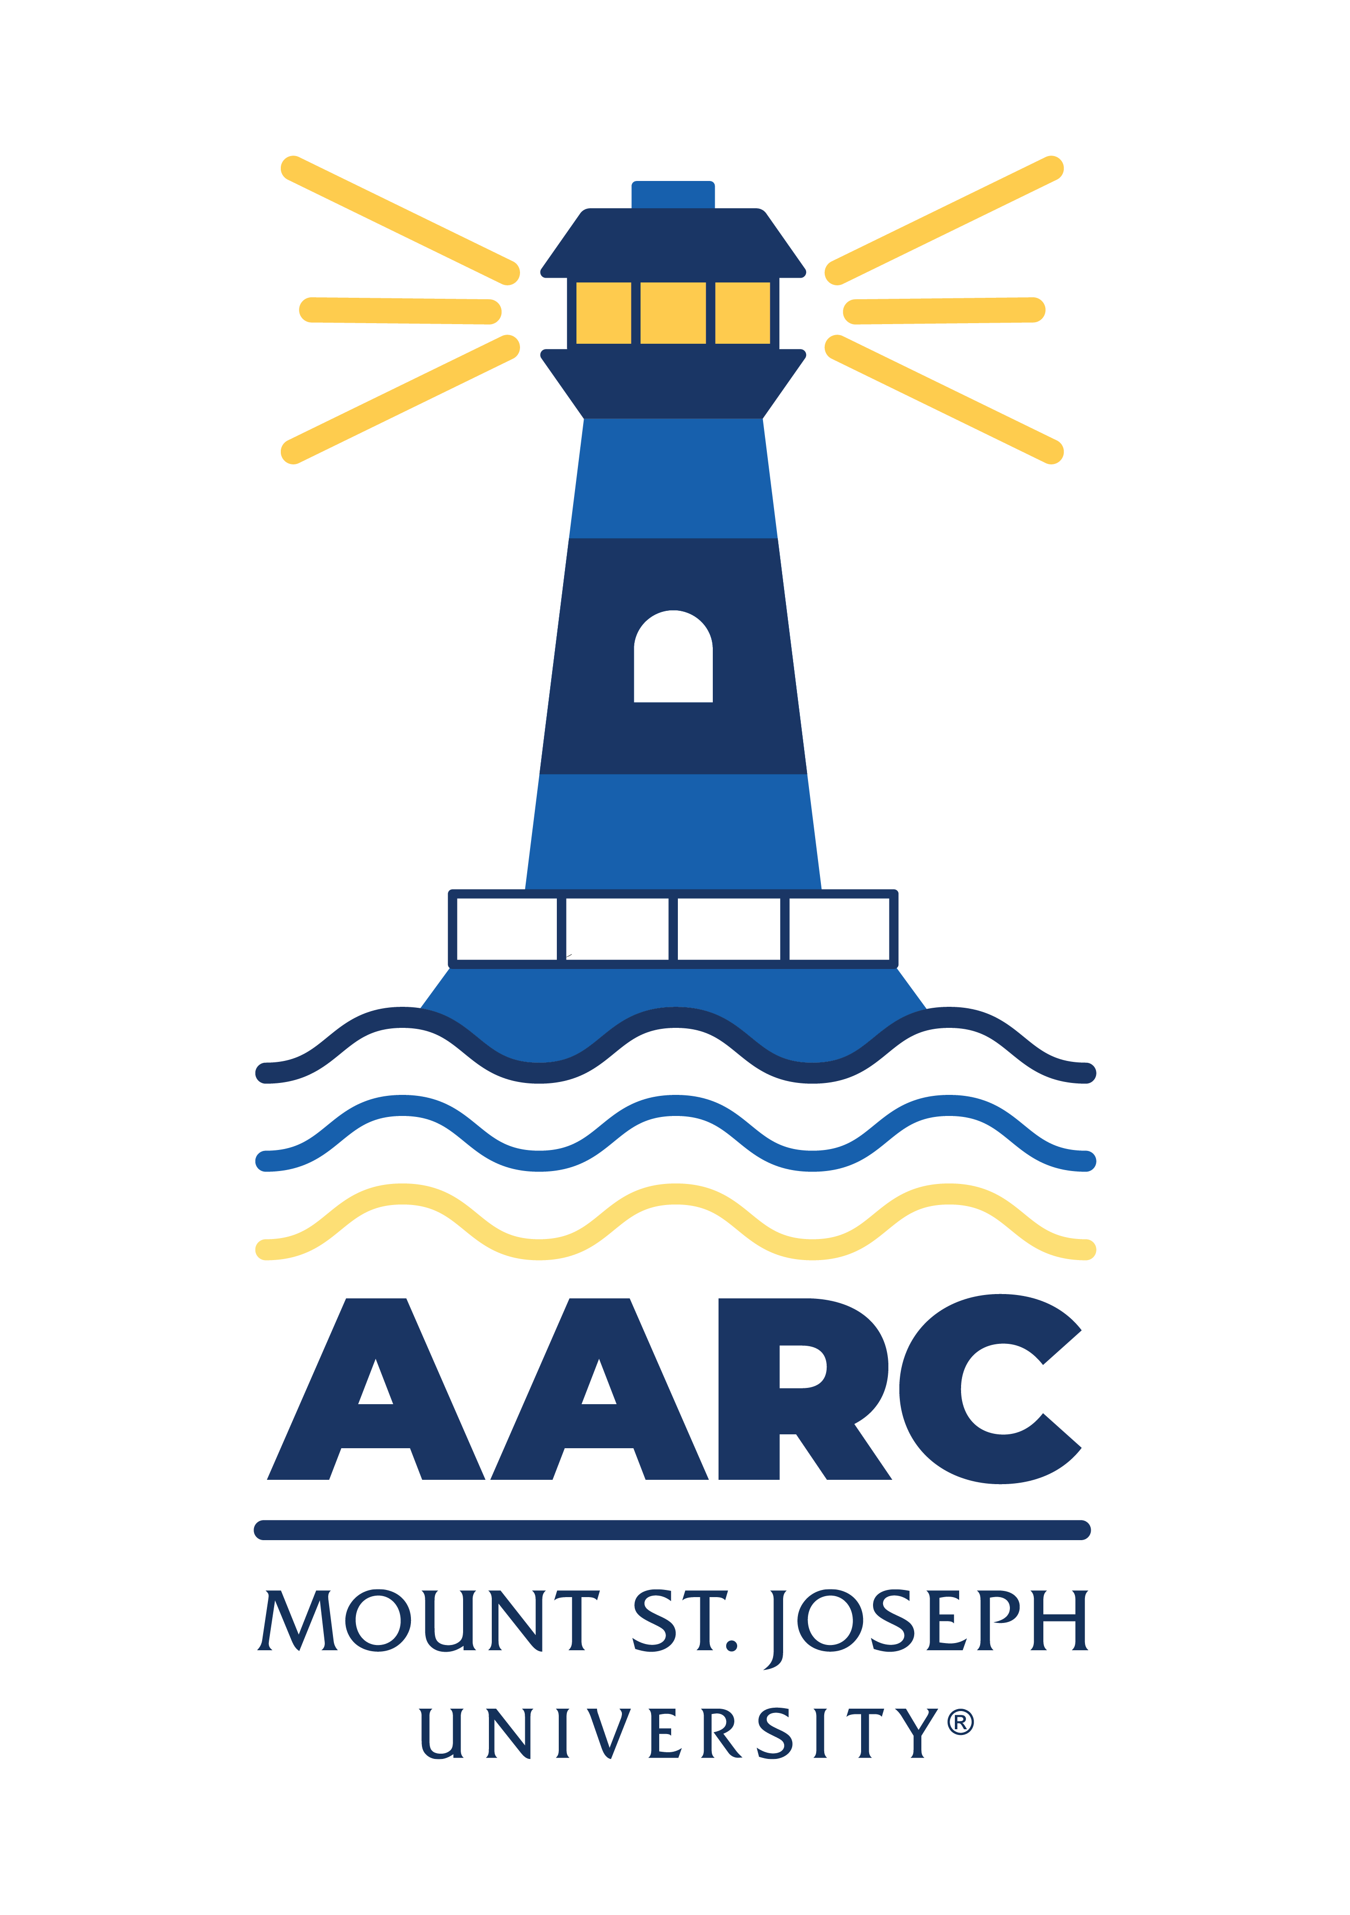

GOT A QUESTION? ask advising.

The Academic Advising Resource Center (AARC) is located in the Conlan Center, around the corner from the Registrar Office. Our team is here to help you any and all academic or advising questions. Drop-ins are welcome!

important deadlines

First-year students who haven’t completed required online trainings will have a hold on their accounts that blocks registration. Questions about that can be directed to peggy.welge@msj.edu.

Advising for S225 is still going strong and registration has opened for some students. If you still need to register for Spring classes, or if you’re dealing with waitlists and closed courses, remember that we’re here to help. Email us (advising@msj.edu) if you’re in a registering/scheduling pickle and need some advice or assistance.

Registration stays open until next semester. Email or drop by so we can get you set up for a great Spring semester!

life hacks with bpw

Q: Papers, projects, exams! How can I get all this research, writing, and studying done in three weeks?

A: One article, one sentence, one study question at a time. There’s a great book of writing advice by Anne Lamott called Bird By Bird. As a kid, Lamott’s brother had a research paper due about birds of North America. He put it off until the night before, when panic set in. He asked his dad for help. It seemed impossible: too little time—too many birds. His father devised a plan. Take it “bird by bird” until the paper was finished. And by morning, it was.

There’s a note on my office door, a line by Samuel Beckett: “Grain upon grain, one by one, and one day, suddenly, there's a heap, a little heap, the impossible heap.” Step by step, bird by bird, grain by grain. Don’t let the mountain in the distance overwhelm you. Chip away at papers, projects, and exam prep—starting now. You’ll make small, measurable progress on all final assignments. Keep cool. Don’t panic. Put one foot in front of the other.

If you focus on the whole shebang and you’ll cry. Take it bird by bird, and you’ll be fine.

KATE’S CORNER (academic survival tips)

Only two weeks of classes left in the semester, and then finals. You’ve worked hard, learned a lot, and hopefully started to find your rhythm as a college student. But remember, the semester isn’t over yet, and how you finish is just as important as how you started. Here are some reminders to help you finish well:

- Stay Organized: Check syllabi and Blackboard for deadlines. Don’t let important tasks sneak up on you.
- Ask for Help: If you’re feeling overwhelmed, reach out to your professors, advisors, or campus resources.
- Prioritize Self-Care: Eat well, sleep enough, and take breaks to stay focused.
- Reflect and Adjust: Think about what’s worked this semester and what hasn’t. Use this insight to improve.

Here are two helpful documents. The first will help you prepare for finals: finals.docx. The second provides useful study tips: STUDY STRATEGIES FOR SUCCESS.pdf.

LIBRARY SUPPORT

Off-campus Access to Library Resources

Working hard on research over break? Not on MSJ campus but still researching? Remember that MSJ Library’s databases are single-sign-on (SSO), so when you’re off-campus you can use your MSJ login—what you use for Blackboard!—to access library materials.

Wellness Tips

This November, the Wellness Center invites you to embrace Gratitude. Practicing gratitude helps shift our focus away from the mind’s natural negativity bias, allowing us to appreciate what we’re truly thankful for. A simple way to start is to set aside a few minutes each day to write down three things you’re grateful for. Use the attached journal to help you begin! If you're interested in exploring more gratitude practices, try Gratitude Meditation from Greater Good in Action.

Pass Program

If you’re taking part in the PASS Program, remember you need to meet with Jadah Jackson every two weeks. If you missed a meeting, email Jadah asap to get back on schedule: jadah.jackson@msj.edu. New to PASS? Learn more about it here: https://www.msj.edu/academics/academic-resources/pass-program/index.html.

FOLLOW US ON INSTAGrAM!
Keep up with crucial dates and info about advising by following msj_advising on Instagram. We’ll be launching soon with a brand new logo and helpful tips and timelines for students. Follow us now so you’re ready later!

