ACADEMIC ADVISING RESOURCE CENTER

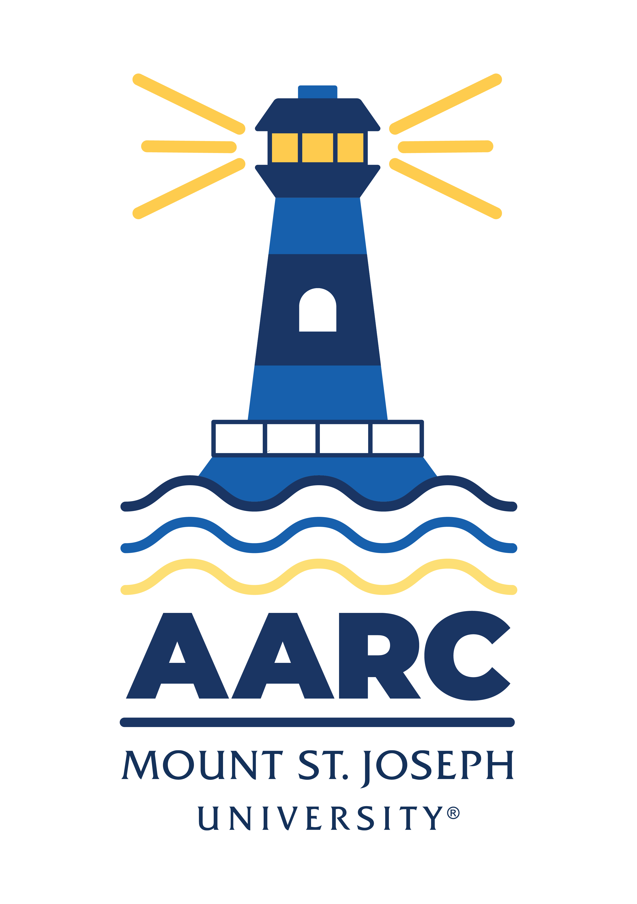
  - Newsletter— December 5, 2024

GOT A QUESTION? ask advising.

The Academic Advising Resource Center (AARC) is located in the Conlan Center, around the corner from the Registrar Office. Our team is here to help you any and all academic or advising questions. Drop-ins are welcome!

important deadlines

If you still need to register for Spring classes or if you’re stuck in waitlist purgatory, remember we’re here to help. Email us (advising@msj.edu) if you’re in a registering/scheduling pickle and need some advice or assistance. We are more than happy to help strategize back-up classes or to help you communicate with professors about waitlists.

Registration stays open until next semester. Email or drop by so we can get you set up for a great Spring semester!

Mary’s Holiday TIP

Every year, my family enjoys looking at holiday decorations: the lights, inflatables, wreaths, trees, etc. But I have some rules about how best to decorate. I’m always open for discussion, but here are my simple suggestions:

1) Don’t mix white lights and color lights
2) Don’t mix big bulbs and little bulbs
3) If you’re gonna go tacky, go BIG! One inflatable? Nope, need like 5 or more. Lights everywhere. Think Griswold home in Christmas Vacation. Google it if you don’t understand my reference.
4) Don’t cheat the bush (those net lights that just get laid on part of the bush but miss most of the bush- they cheat the other part of the bush from being festive)
5) Blinking lights either need to be all over random or orderly. No one random string should be blinking while everything else stays lit.
6) Go either tacky or tasteful. You decide, but either are fine if you follow simple rules.

What rules do you have for festive decorations? Share your pics with us on Instagram by tagging @msj_advising!

life hacks with bpw

Q: What’s NASA got to do with it? (I’m so behind on my final work I want to lay down and die!)

A: In the film The Martian, Matt Damon explains his NASA mindset: “Everything's going to go south and you're going to say, this is it. This is how I end. Now you can either accept that or you can get to work…You solve one problem. And you solve the next one. And then the next. If you solve enough problems, you get to come home.”

We tend to over-complicate things when we’re feeling behind—or, worse, we freeze and do nothing. My previous tip was about chipping away at your work a little each day. But now, as finals weeks is upon us, if you put things off until now, or you’ve just got tons more work to do, it may be time to change your tactic and adopt the “one problem at a time” approach. Got a test tomorrow, a paper due the next day, and another test the day after that? Just study for the first test; when the test is over, write the paper; when the paper is done, study for the next test.

Solve the most urgent problem first. Then move to the next one. Is it ideal? Maybe not. But it’s not overwhelming.

You could also prioritize what to focus on based on a) the most important class for you to do well in b) the impact each grade will have on your course GPA. For example, if you’ve got an A in the first class and getting a crappy grade on the final won’t destroy your overall grade, but getting an F on the paper that’s due could result in failing that class—well, that’s something to consider. Maybe work a little on the paper before you study for the test, if the paper is more important. Your test may stink, but getting a B in one course because of a bad test is better than getting an F in another course because you ran out of time to finish a paper you desperately needed to do well on. Whatever strategy you use, it’s good to sit down and chart things out. And stick to the plan (waffling never helps).

Of course, my recommendation is always “talk to your professors.” Most professors will be honest with you about your grades and what will happen if you do poorly, or fail, a final test/paper. If you’re feeling like you don’t have enough time to do your best on all your remaining work, why not check in with your professors so you can make the most informed plan about where to focus your energy? You can also visit the Academic Advising office where Mary or Jadah would be happy to help you make the best decisions possible, given your specific situation.

Just. Don’t. Panic. You will get home for break if you take a deep breath, then get to work one problem at a time.

KATE’S CORNER (academic survival tips)

Contact kathryn.mitchell@msj.edu if you have interest in taking Mount 102 in the spring, or for more tips about how to finish your semester strong during finals week.

LIBRARY SUPPORT

Research Tips: Finding Full-Text

Need full-text of an article in a hurry? No time to ILL Request the article? Make sure to filter search results within databases on the left-hand side to “Full Text” or utilize LibKey Nomad’s browser extension. If you need more help with anything research-based, remember you can stop by the library or request a chat on online for assistance!

Wellness Tips

As we head into exam week, here are some tips to help you stay on top of your game:

- Get enough sleep to recharge your mind.
- Stay hydrated—your brain loves water!
- Eat properly to fuel your focus.
- Plan ahead and prioritize tasks.
- Schedule time for exercise to manage stress.
- Practice a mindful moment using resources like the Uwill Wellness Library.
- Celebrate your successes, big or small.

Remember, if you need support, you can schedule an appointment with a counselor by calling 513-244-4949 or emailing Wellness.Center@msj.edu.

FOLLOW US ON INSTAGrAM!
Keep up with crucial dates and info about advising by following msj_advising on Instagram.

